**IDEATION PHASE**

**Define the Problem Statements**

|  |  |
| --- | --- |
| **NAME** | **DINESH M** |
| **TEAM ID** | **8E2B4970F2F803A9B084E092E573C2AC** |
| **PROJECT NAME** | **Creating a sponsored post for Instagram** |

**Customer Problem Statement Template:**

Create a problem statement to understand your customer's point of view. The Customer Problem Statement template helps you focus on what matters to create experiences people will love.

A well-articulated customer problem statement allows you and your team to find the ideal solution for the challenges your customers face. Throughout the process, you’ll also be able to empathize with your customers, which helps you better understand how they perceive your product or service.

**THE PROBLEM STATEMENT IN CREATING A SPONSORED POST FOR INSTAGRAM**

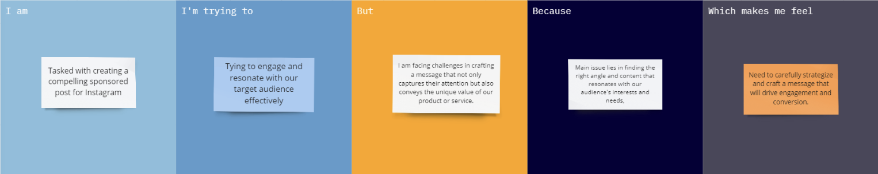

**REFERENCE LINK:**

<https://miro.com/app/board/uXjVMLRn6Jo=/?share_link_id=61727472141>

The various problem statements are defined by the various persons related to workers health and safety are tabulated below:

|  |  |  |  |  |  |
| --- | --- | --- | --- | --- | --- |
| **Problem Statement (PS)** | **I am (Customer)** | **I’m trying to** | **But** | **Because** | **Which makes me feel** |
| PS-1 | Sponsored post creator | Engage and resonate with our target audience effectively | I am facing challenges in crafting a message that not only captures their attention but also conveys the unique value of our product or service | The main issue lies in finding the right angle and content that resonates with our audience's interests and needs | the need to carefully strategize and craft a message that will drive engagement and conversion. |